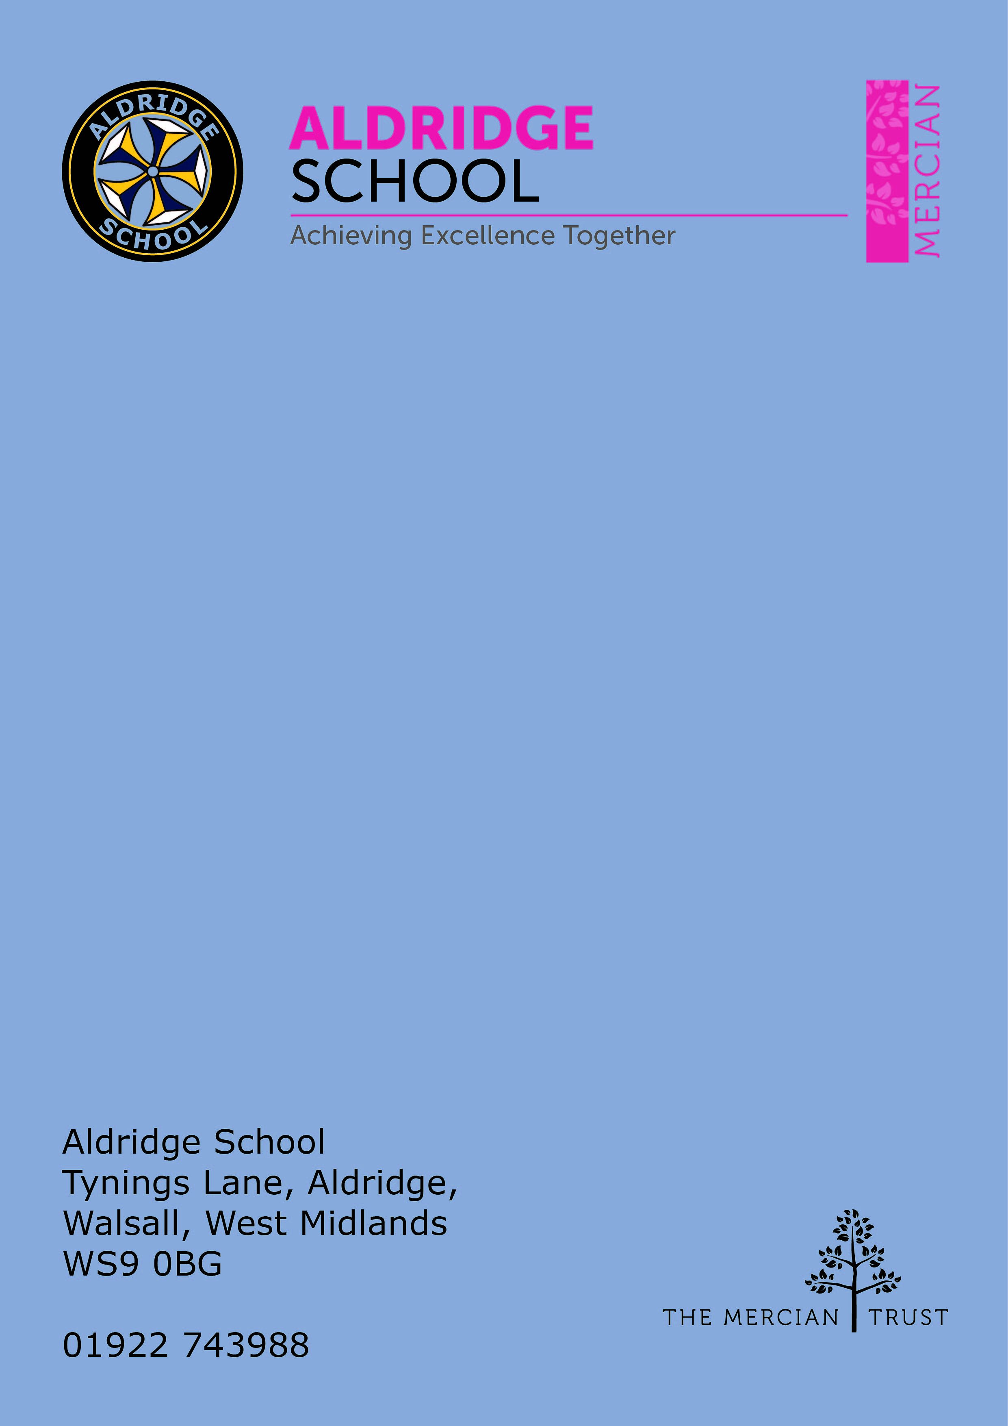

Application Pack

Learning Support Assistant (19hrs)


About Aldridge School – a Founder Academy of the Mercian Trust

About The Mercian Trust

Person Specification
How to Apply

Job Description

About Aldridge School - a Founder Academy of the
Mercian Trust



Benefits of Working at Aldridge School

- Everyone has the highest expectations of behaviour, with all staff reinforcing those expectations
- A clear system of sanctions which is applied consistently so staff don't have battles with students
- Senior Leadership are very visible
- Excellent pastoral support offered through House Offices
- Simply Health, healthcare package provided for all staff
- CPD tailored specifically to staff needs, based off their feedback
- Time for staff to put new things into action
- Non-hierarchical approach to professional development - there are things a senior leader can learn from an ECT and vice versa
- Targeted support plans for teachers who are struggling
- Regular Staff, Faculty and Pastoral briefings to support good communication
- Comprehensive support for NQTs with dedicated mentors and regular meetings
- Performance Management is tailored to faculty and individual needs. Data targets are not used punitively but aspirationally. We begin from the assumption that everyone will get the pay rise unless they haven't done all they can to improve student outcomes
- We are constantly streamlining all systems and processes so they take less time
- Open door Senior Leadership Team - no concern is ever too small
- Countless opportunities to get involved with the wider life of the school - Duke of Edinburgh, school performances, sports teams, music
- Contributions of staff recognised through 'Above and Beyond' draws each half term
- MAT ‘Employer of Choice’ opportunities such as Simply Health Healthcare plan, an electric car scheme and access to mylifestyle with a wide range of employee perks.

About the SEN Department

Staff

The student development team is led by the SENCO. We have 7 Higher Level Teaching Assistants/Senior Learning Support Assistants, 1 SEN Behaviour and Learning Practitioner 15 Learning Support Assistants and an Assistant SENCO. The team work well together to provide effective support for students. Our aim is to remove barriers to students’ learning so that all students can achieve their potential.

The Student Development Department

The team work with students who have special educational needs across all year groups. This consists of support in the classroom, as well as 1-1 support or small group support outside of the classroom. The teaching assistants use a range of data to analyse students’ progress and to target interventions to meet the students’ needs.
The department offers a range of interventions to support students’ academic and social, emotional and communication needs. Interventions include programmes such as Lego Therapy, Pragmatics, Rapid Reading and Nessy . These interventions are delivered by support staff at various times throughout the day, including before and after school.
The team also work closely with parents/ carers, as well external agencies. Support staff play an important role in supporting students with some of the most complex needs and promoting their inclusion within the school community.



The Mercian Trust

Aldridge School is an academy in The Mercian Trust.

The Mercian Trust brings nine very different and individual schools together as a single Multi-Academy Trust or MAT.

The nine schools are unique in their identity and united by their ambition to offer the best possible future for their students.

The nine schools are:
- Aldridge School
- Queen Mary's Grammar School
- Queen Mary's High School
- Shire Oak Academy
- The Ladder School
- Walsall Studio School
- Q3 Academy Great Barr
- Q3 Academy Langley
- Q3 Academy Tipton

Each School has its own distinct ethos and approach, but we have this over-arching aim in common: we prepare all our students to enjoy life to the full by inspiring them to:

- Realise their potential as learners
- Thrive in the world of work
- Make a positive contribution to the local, national and international community

The Mercian Trust respects the autonomy of its member schools but, through collaboration, fosters

Job Description

Duties

This job description describes in general terms the normal duties which the postholder will be expected to undertake. However, the job or duties described may vary or be amended from time to time without changing the level of responsibility associated with the post.

Teaching and learning

- Assist in the educational and social development of key pupils under the direction and guidance of the head teacher, SENCO and class teachers.
- Support in the implementation and running of programmes aimed to promote pupil progress and social development.
- Provide support for individual students, who have recently made the transition to secondary education, inside and outside the classroom to enable them to fully participate in activities
- Support with the differentiation of teaching and learning within the revised SEN curriculum at key stage 3.
- Work with other professionals as necessary
- Support students with emotional or behavioural problems and help develop their social/emotional skills.
- Keep a record of the nature and effectiveness of support/intervention strategies used with students and assist in the implementation of Learning
- Plans for students and help monitor their progress via Support Records

Administrative duties

- Prepare and present displays of students' work
- Support class teachers in differentiation and other tasks to support teaching
- Support tracking of pupil progress data
- Undertake other duties from time to time as the head teacher requires

Standards and quality assurance

- Support the aims and ethos of the school
- Set a good example in terms of dress, punctuality and attendance
- Attend team and staff meetings
- Undertake professional duties that may be reasonably assigned by the head teacher
- Be proactive in matters relating to health and safety
- Be committed to safeguarding and promoting the welfare of children and young people


Person Specification

The employee will need to demonstrate the following requirements in order to perform each of the main activities of the job safely and effectively.

Skills / Knowledge

- Ability to show initiative in supporting the effective inclusion of an individual child and groups of students within the mainstream setting.
- Use of other equipment technology, e.g. ipad, laptop, photocopier.
- Full working knowledge and an understanding of relevant polices, codes of practice and an awareness of relevant legislation.
- Working knowledge and general understanding of national curriculum and other support programmes and strategies.
- Understanding of the principles of child development and learning processes.
- Ability to differentiate for the needs of students effectively
- Ability to self–evaluate learning needs and actively seek learning opportunities.
- Ability to relate well to children and adults
- Empathy and understanding for children who have social, emotional and mental health/ communication needs
- Work constructively as part of a team, understanding classroom roles and responsibilities and your own position within these.
- Very good literacy and numeracy skills.

The following will be advantageous but not a requirement.

Experience

- Experience of working with students who are working significantly below age expectations
- Experience and knowledge of working with the Primary School curriculum and/ or experience of working in a Special School setting.
- Supporting children with Special Educational Needs
- Running programmes such as pragmatics, ARROW and CATCH UP
- Experience of working with students who have a visual impairment.

Qualifications
- NVQ 3 for Teaching Assistants, or equivalent qualifications or experience
- First aid training.



How to Apply
Grade 3 Point 4 - 6
(£21,189-21,968)

Term Time only plus 5 training days
19 hours per week
Actual Salary £10,209

Closing Date
09:00am Friday 23rd February 2024

Start Date
As soon as possible

Applying
To apply please complete an associate staff application form which can be found on our website and a letter explaining your interest. Please email your application to applications@aldridgeschool.org.uk
Advert
Learning Support Assistant
19 hours per week
39 weeks per year (Term Time plus 5 additional training days)
Salary Scale: Grade 3 Point 4-6 (£21,189 - £21, 968 pro rata)
Actual Salary: 19hrs £10,209

Aldridge School - An Academy is a successful converter academy with a good track record of results at both GCSE and A Level. Our most recent Ofsted inspection (February 2017) rated us as Good in all areas. This is an excellent opportunity for inspired, committed and enthusiastic people to join a thriving department in this popular and successful school. Our motto 'Achieving Excellence Together' is at the heart of our work.

You will be required to support pupils with a variety of needs and therefore should have an interest in supporting students with special educational needs. This may involve working with less able pupils or those who need help to reach their potential at a higher level. Enthusiasm, the ability to work in a team and the commitment to raising pupil achievement and removing barriers to pupils’ learning are essential. A GCSE qualification in English/Mathematics would be an advantage as would a teaching assistant qualification.

To apply please complete an associate staff application form which can be found on our website and a letter explaining your interest. Please send applications to applications@aldridgeschool.org.

Aldridge School - An Academy is committed to safeguarding and promoting the welfare of children and young people and expect all staff and volunteers to share in this commitment. The post is subject to enhanced DBS and safeguarding checks.

For further information please go to our web site www.aldridgeschool.org or contact Mrs R Knight 01922 743988 ex 2224.

