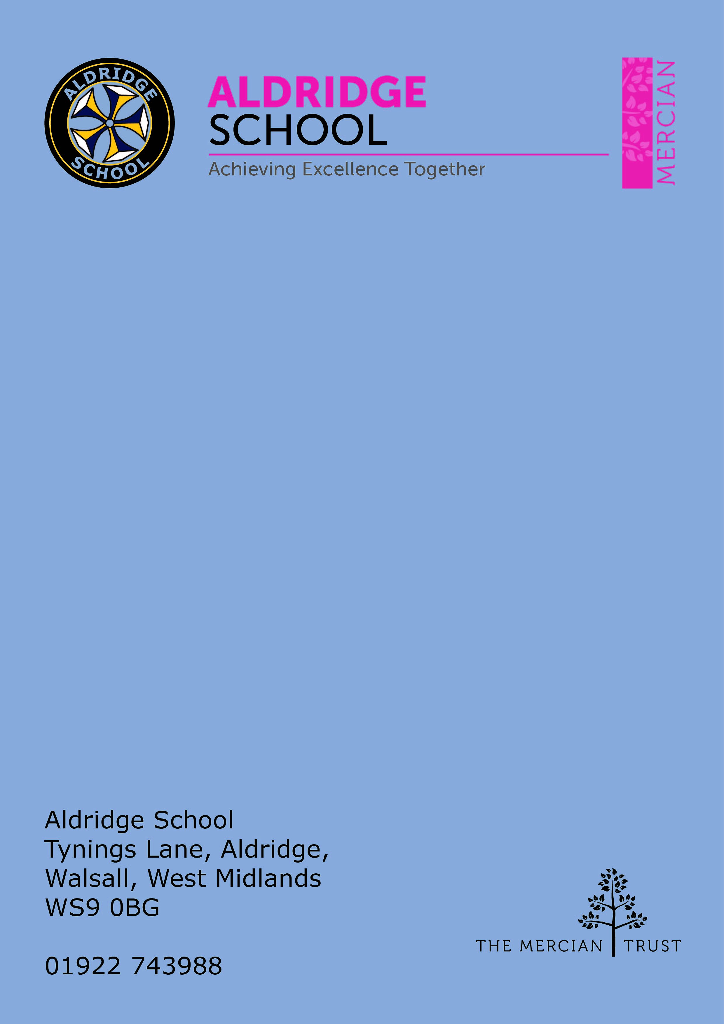

Application Pack

Behaviour Support Assistant


About Aldridge School – a Founder Academy of the Mercian Trust

About The Mercian Trust

Person Specification
How to Apply

Job Description

About Aldridge School

Thank you for taking the time to find out more about Aldridge School. This pack is intended to give you information about this role and our school's broader vision and ethos. Further background information is available in our Prospectus and Sixth Form Prospectus on our website.

We are a comprehensive school of over 1500 students situated near the centre of Aldridge village. We believe that it is our responsibility to work to meet the needs of every individual student, challenging them to achieve their best, supporting them to become responsible young adults and preparing them for their next steps into the world of work or further education.

Aldridge School is a good school (Ofsted 2022). It is a school which is proud of its traditions and successes which have been achieved through hard work and high expectations. In particular, we encourage our students to be Respectful, Responsible, Resilient and Ready to learn in order that they will be happy and successful at school and in the wider world beyond.

Aldridge School has a dedicated, talented and conscientious team of staff who work together to provide a high standard of teaching, excellent pastoral care and professional support services. Our broad curriculum is designed to meet national expectations, be relevant and interesting, support our students in achieving the best possible standards in external examinations and to equip them with the skills they need to be successful in adult life.

At Aldridge School we have a popular and thriving Sixth Form. We are very proud of our students' success with over 80% securing places at some of the top Universities and on Higher Apprenticeships last year. We offer a very broad range of both academic and vocational courses at level 3, ensuring that Aldridge School Sixth Form is an option for a wide range of students.

We also enjoy strong links with surrounding primary schools, working with students in Years 5 and 6 including work in Science, Maths, English, Performing Arts and Enterprise. We are proud of our community and we work hard to promote this pride in all our partnerships, so that we can make sure that future students from these schools enjoy an easy, enjoyable transition to Aldridge School.

Students at Aldridge School are friendly, polite and respectful. Strong relationships between staff and students contribute significantly to ensuring that students are happy and feel safe.

If you would like to find out more, please contact us to arrange a visit to see our school at work. We look forward to meeting you.

Benefits of Working at Aldridge School

- Teachers are all provided with a laptop to support their teaching
- 21/25 periods of teaching per week maximum, less as an ECT
- No pressure to "put on a show" in lessons. A culture of typicality is reinforced by no lesson grading (outstanding, good etc.)
- No need to write lesson plans of any kind
- Everyone has the highest expectations of behaviour, with all staff reinforcing those expectations
- A clear system of sanctions which is applied consistently so staff don't have battles with students
- Senior Leadership are very visible
- Excellent pastoral support offered through House Offices
- CPD tailored specifically to staff needs, based off their feedback
- Time for staff to put new things into action
- Non-hierarchical approach to professional development - there are things a senior leader can learn from an ECT and vice versa
- Targeted support plans for teachers who are struggling
- Regular Staff, Faculty and Pastoral briefings to support good communication
- Comprehensive support for ECTs with dedicated mentors and regular meetings
- Performance Management is tailored to faculty and individual needs. Data targets are not used punitively but aspirationally. We begin from the assumption that everyone will get the pay rise unless they haven't done all they can to improve student outcomes
- We are constantly streamlining all systems and processes so they take less time
- Open door Senior Leadership Team - no concern is ever too small
- Countless opportunities to get involved with the wider life of the school - Duke of Edinburgh, school performances, sports teams, music
- Contributions of staff recognised through 'Above and Beyond' draws each half term


The Mercian Trust

Aldridge School is an academy in The Mercian Trust.

The Mercian Trust brings nine very different and individual schools together as a single Multi-Academy Trust or MAT.

The nine schools are unique in their identity and united by their ambition to offer the best possible future for their students.

The nine schools are:
- Aldridge School
- Queen Mary's Grammar School
- Queen Mary's High School
- Shire Oak Academy
- The Ladder School
- Walsall Studio School
- Q3 Academy Great Barr
- Q3 Academy Langley
- Q3 Academy Tipton

Each School has its own distinct ethos and approach, but we have this over-arching aim in common: we prepare all our students to enjoy life to the full by inspiring them to:

- Realise their potential as learners
- Thrive in the world of work
- Make a positive contribution to the local, national and international community

The Mercian Trust respects the autonomy of its member schools but, through collaboration, fosters strengths that are greater than the sum of its parts. Working together as a Multi Academy Trust provides a framework for sharing expertise and enthusiasm, resources and ideas.


Job Description & Person Specification

Post: Behaviour Support Assistant
Responsible to: Assistant Headteacher in charge of Behaviour
Salary: Grade 5 point 9 – 17 (£23,194 - £26,845 pro rata)
Actual Salary £21,701 - £24,856)
Working hours 37 hours a week, 39 weeks plus 5 INSET days

PURPOPSE:
We are looking to recruit a dynamic and proactive individual to become part of the school's Behaviour Team. This is an excellent and exciting role which will involve supporting the management of our newly renovated Behaviour Centre. The successful individual will be required to build and maintain strong and productive relationships with our students, whilst leading and actioning our behaviour systems and procedures across the school. This post is suitable for someone with experience of working with hard-to-reach children in an educational setting and someone who has the ability to support students in building resilience and emotional intelligence in order to ensure students are given the best chance of success.

Principal duties and responsibilities

- Work with the Assistant Headteacher for Behaviour to ensure our behaviour policy is implemented through the school day
- Help organise our centralised detention system, which is run each afternoon by SLT, Pastoral Leaders, Faculty Leaders and teaching staff
- Support in the day to day running of the Internal Exclusion Room with the team of other Behaviour Support Assistants and the IER Manager
- Monitor the allocation of behaviour points using Class Charts and supporting the AHT Behaviour with the analysis of the data
- Visiting lessons to support students and teachers
- Work alongside colleagues in the Pastoral Team and Behaviour Team to support the students
- To attend any meetings relevant to the Behaviour and Pastoral Teams
- Liaise with parents/carers where necessary

Desirable qualifications

There are no essential qualifications for this role, however the following would be beneficial:

- GCSE or equivalent in English and maths
- Experience of working with children with emotional, behavioural and social problems
- Prior experience of working in schools
- Ability to use and interpret data
- Ability to present information to a variety of audiences, Pastoral Staff, teachers, parents, Senior Leadership Team
- Be self-motivated and enthusiastic and able to remain positive under challenging circumstances
- Have excellent administration and organisational skills, with a good working knowledge of ICT systems
- Have excellent interpersonal skills and empathy to become a valued member of the Behaviour Team



How to Apply

Salary Scale:
Grade 5 Scale Point 9-17 (£23,194 - £26,845 pro rata)
Actual Salary £20,038 - £23,192

Closing Date
09:00am Monday 19th February 2024

Start Date
As soon as possible

Visits to School
For further information, please contact the school either by email info@aldridgeschool.org.uk or by telephoning on 01922 743988 ex 2224

Applying
Apply via application form to applications@ald.merciantrust.org.uk
