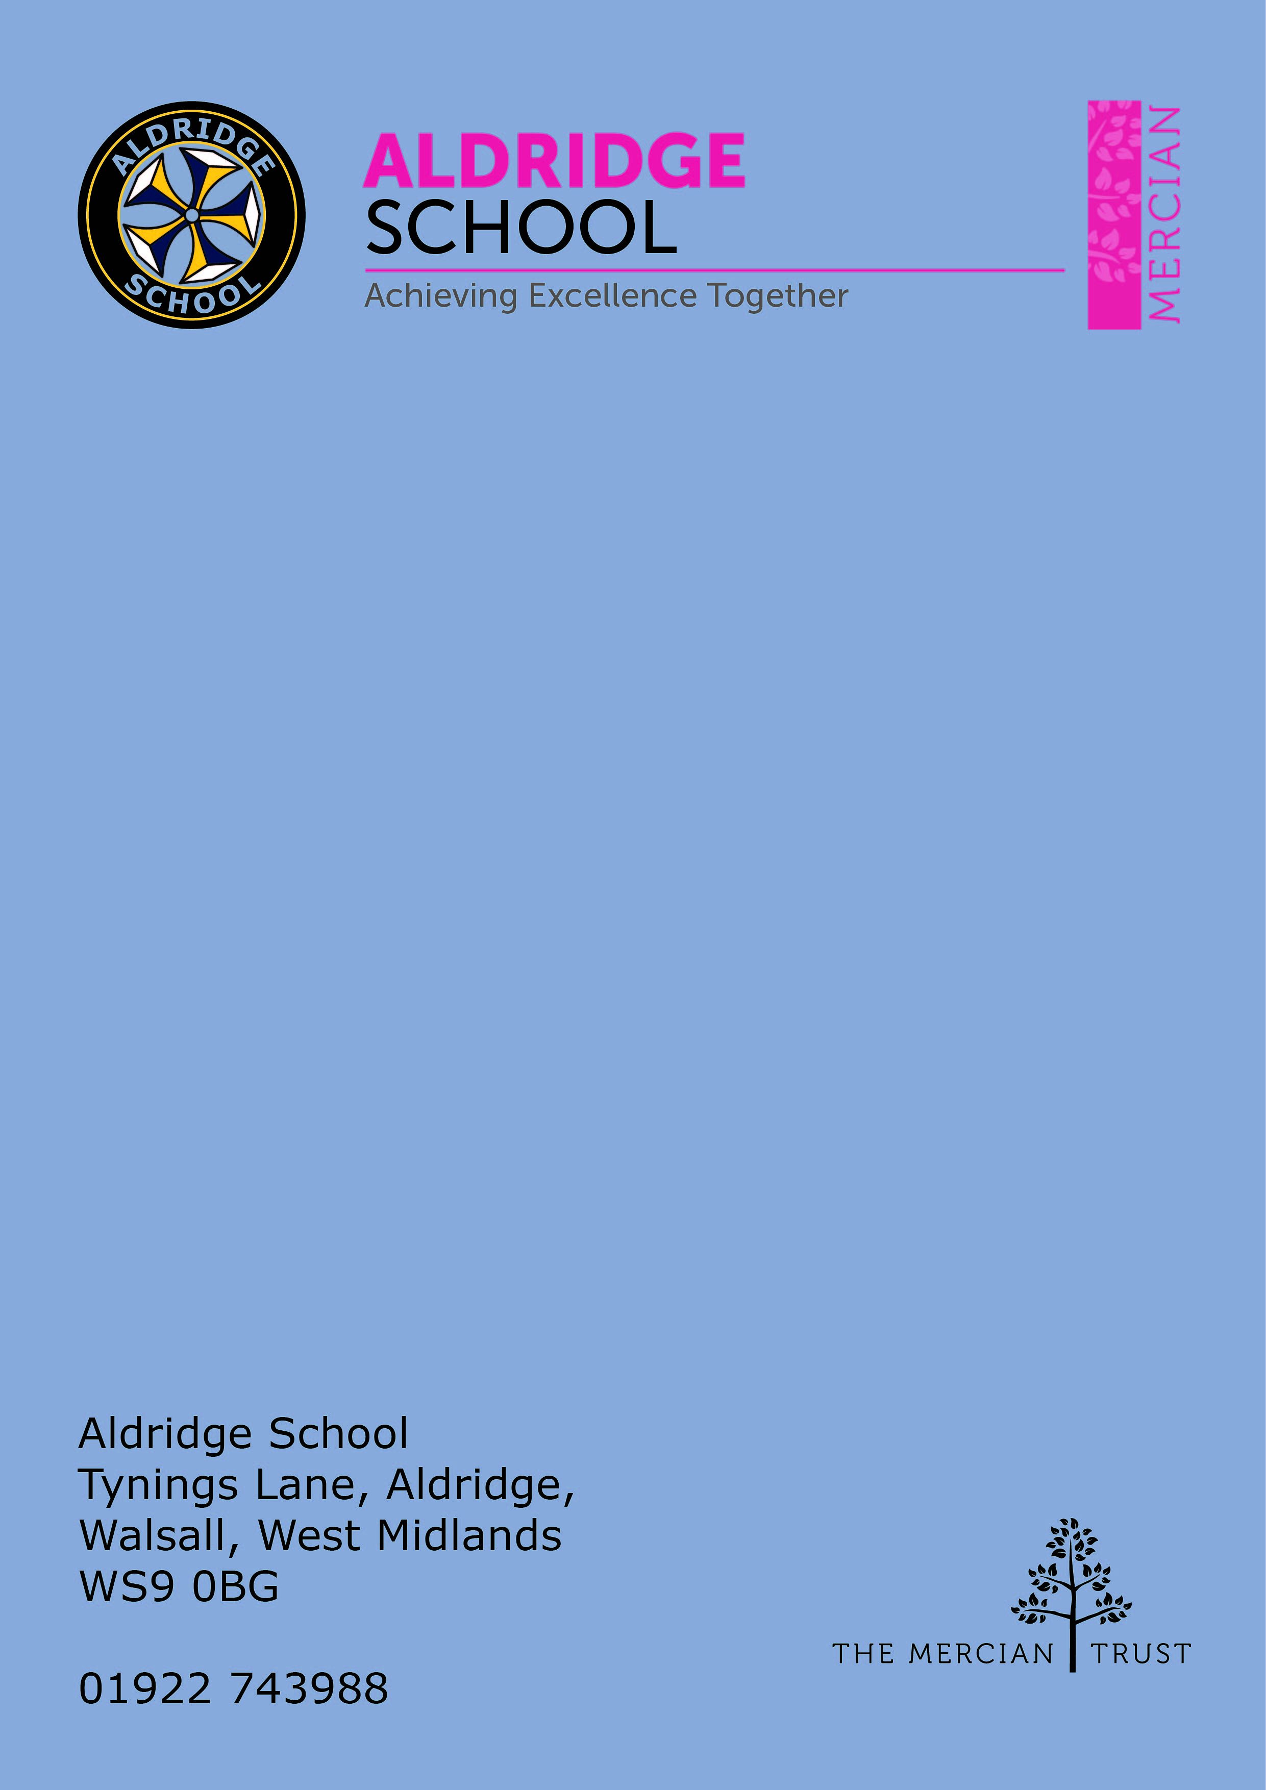

Application Pack

Examinations Invigilator
(Casual / Permanent)



About Aldridge School – a Founder Academy of the Mercian Trust

About The Mercian Trust

Person Specification
How to Apply

Job Description

About Aldridge School

Thank you for taking the time to find out more about Aldridge School. This pack is intended to give you information about this role and our school's broader vision and ethos. Further background information is available in our Prospectus and Sixth Form Prospectus on our website.

We are a comprehensive school of over 1500 students situated near the centre of Aldridge village. We believe that it is our responsibility to work to meet the needs of every individual student, challenging them to achieve their best, supporting them to become responsible young adults and preparing them for their next steps into the world of work or further education.

Aldridge School is a good school (Ofsted 2022). It is a school which is proud of its traditions and successes which have been achieved through hard work and high expectations. In particular, we encourage our students to be Respectful, Responsible, Resilient and Ready to learn in order that they will be happy and successful at school and in the wider world beyond.

Aldridge School has a dedicated, talented and conscientious team of staff who work together to provide a high standard of teaching, excellent pastoral care and professional support services. Our broad curriculum is designed to meet national expectations, be relevant and interesting, support our students in achieving the best possible standards in external examinations and to equip them with the skills they need to be successful in adult life.

At Aldridge School we have a popular and thriving Sixth Form. We are very proud of our students' success with over 80% securing places at some of the top Universities and on Higher Apprenticeships last year. We offer a very broad range of both academic and vocational courses at level 3, ensuring that Aldridge School Sixth Form is an option for a wide range of students.

We also enjoy strong links with surrounding primary schools, working with students in Years 5 and 6 including work in Science, Maths, English, Performing Arts and Enterprise. We are proud of our community and we work hard to promote this pride in all our partnerships, so that we can make sure that future students from these schools enjoy an easy, enjoyable transition to Aldridge School.

Students at Aldridge School are friendly, polite and respectful. Strong relationships between staff and students contribute significantly to ensuring that students are happy and feel safe.

If you would like to find out more, please contact us to arrange a visit to see our school at work. We look forward to meeting you.

Benefits of Working at Aldridge School

- Everyone has the highest expectations of behaviour, with all staff reinforcing those expectations
- A clear system of sanctions which is applied consistently so staff don't have battles with students
- Senior Leadership are very visible
- Excellent pastoral support offered through House Offices
- CPD tailored specifically to staff needs, based off their feedback
- Time for staff to put new things into action
- Non-hierarchical approach to professional development - there are things a senior leader can learn from an NQT and vice versa
- Regular Staff, Faculty and Pastoral briefings to support good communication
- Performance Management is tailored to faculty and individual needs. Data targets are not used punitively but aspirationally. We begin from the assumption that everyone will get the pay rise unless they haven't done all they can to improve student outcomes
- We are constantly streamlining all systems and processes so they take less time
- Open door Senior Leadership Team - no concern is ever too small
- Countless opportunities to get involved with the wider life of the school - Duke of Edinburgh, school performances, sports teams, music
- Contributions of staff recognised through 'Above and Beyond' draws each half term


The Mercian Trust

Aldridge School is an academy in The Mercian Trust.

The Mercian Trust brings nine very different and individual schools together as a single Multi-Academy Trust or MAT.

The nine schools are unique in their identity and united by their ambition to offer the best possible future for their students.

The nine schools are:
- Aldridge School
- Queen Mary's Grammar School
- Queen Mary's High School
- Shire Oak Academy
- The Ladder School
- Walsall Studio School
- Q3 Academy Great Barr
- Q3 Academy Langley
- Q3 Academy Tipton

Each School has its own distinct ethos and approach, but we have this over-arching aim in common: we prepare all our students to enjoy life to the full by inspiring them to:

- Realise their potential as learners
- Thrive in the world of work
- Make a positive contribution to the local, national and international community

The Mercian Trust respects the autonomy of its member schools but, through collaboration, fosters strengths that are greater than the sum of its parts. Working together as a Multi Academy Trust provides a framework for sharing expertise and enthusiasm, resources and ideas.


Job Description

Post: Examinations Invigilator
Responsible to: Examinations Officers
Salary Scale: SP4 £11.98 plus Holiday pay £1.45

Purpose and Duties
- Invigilate both public and internal examinations in accordance with Examination Body regulations;
- Supervise candidates held before or after assessments;
- Undertake such administrative tasks as set by the exams officer, which may include but is not limited to taking registers and assisting the Exams Officer with the packing of scripts at the end of exams;
- Promote the ethos and aims of Aldridge School and The Mercian Trust;
- Undertake any other duties as may reasonably be requested by the Headteacher, Senior Leadership Team (SLT) or Exams Officer.

Person Specification
- Accuracy and attention to detail
- Reliability and punctuality
- Ability to use initiative
- Flexible approach to work
- Ability to communicate with candidates and members of staff clearly and accurately
- Effective oral and written communication skills
- Ability to work to predetermined instructions
- Ability to work as part of a team or alone as necessary
- Ability to keep calm under pressure

Review and Amendment
This job description is not exhaustive nor exclusive; it should be seen as enabling rather than restrictive and will be subject to regular review. It does not constitute a fixed list of tasks. It reflects the core priorities of the role which are subject to change depending upon the changing needs of the school and of the students.

Aldridge School – An Academy, is committed to safeguarding and promoting the welfare of children and young people and expect all staff and volunteers to share in this commitment. The post is subject to enhanced DBS and safeguarding checks.


How to Apply

Post Examination Invigilator
Responsible to Exams Officer
Contract and Salary This is a casual position. Hours are dependent on the needs of the School but will be during term-time, Monday – Friday. There will be opportunity to work year-round, with the main exam season taking place in May-June.
£13.43 p/h including holiday pay
Closing Date Friday 26 January 2024 – 09:00am
(We reserve the right to close applications early)
Interview Date TBC
How to apply Complete and submit the Mercian Trust Associate Staff Application Form along with a supporting statement / document outlining how your experience and expertise match the requirements of the role.

Send completed applications to applications@ald.merciantrust.org.uk
